National College of Ireland

Data Structures and Algorithm: TABA



Release Date: 30/04/2021
Due Date: 08/05/2021
Lecturer: Cristina Hava Mutean

Student Name: Alexis Roi Pechon
Student Number: x19358953
Student Email: x19358953@student.ncirl.ie

Question 1. Dijkstra’s Algorithm
Question: Present a real‐world problem (different from the ones from the lecture notes) that can be solved by using Dijkstra algorithm. Explain how the Dijkstra algorithm is used to solve the problem. For exemplification purpose, draw a graph corresponding to the chosen real‐word problem and, illustrate and explain how the Dijkstra algorithm is applied to find the solution to the chosen real‐word problem.

Answer:
In layman terms, the concept behind Dijkstra’s Algorithm is to find the shortest path that connects all the different vertices, sometimes called nodes together. Some uses of Dijkstra’s Algorithm is commonly seen in GPSs, applications like Google Maps, or can be even used in Traffic Information Systems. However, there are some other real-life applications of this type of Algorithm.

For my answer I will be using Dijkstra’s algorithm to help a tourist find the shortest path to 5 different counties so they can see many different parts of Ireland. The weighting that is going to be used will be the time taken to travel from one county to answer and the weighting will be measured using the measurement of time. Meaning that the time taken to travel from one county to another will be measured using minutes.

Diagram:
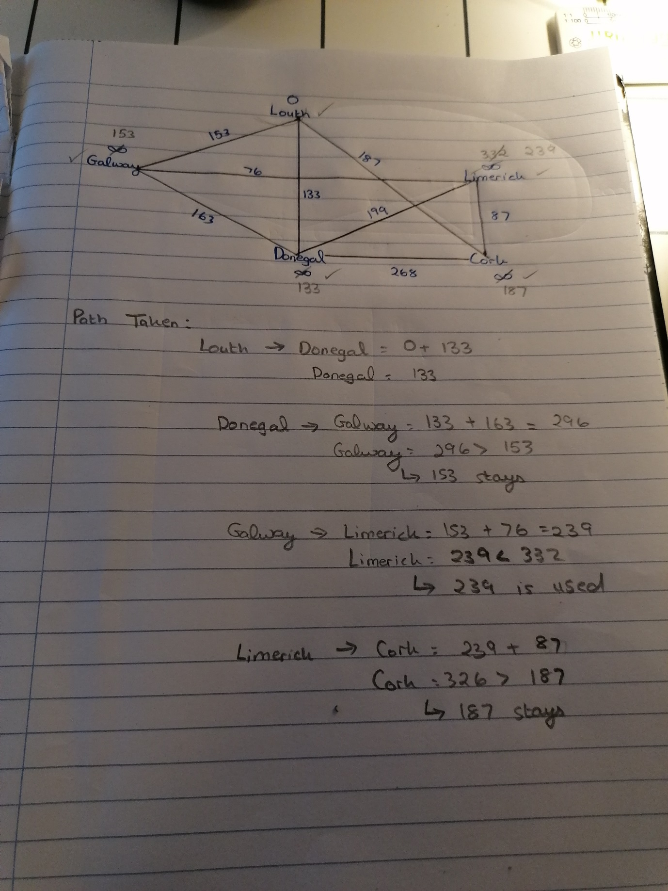

Cloud Table:
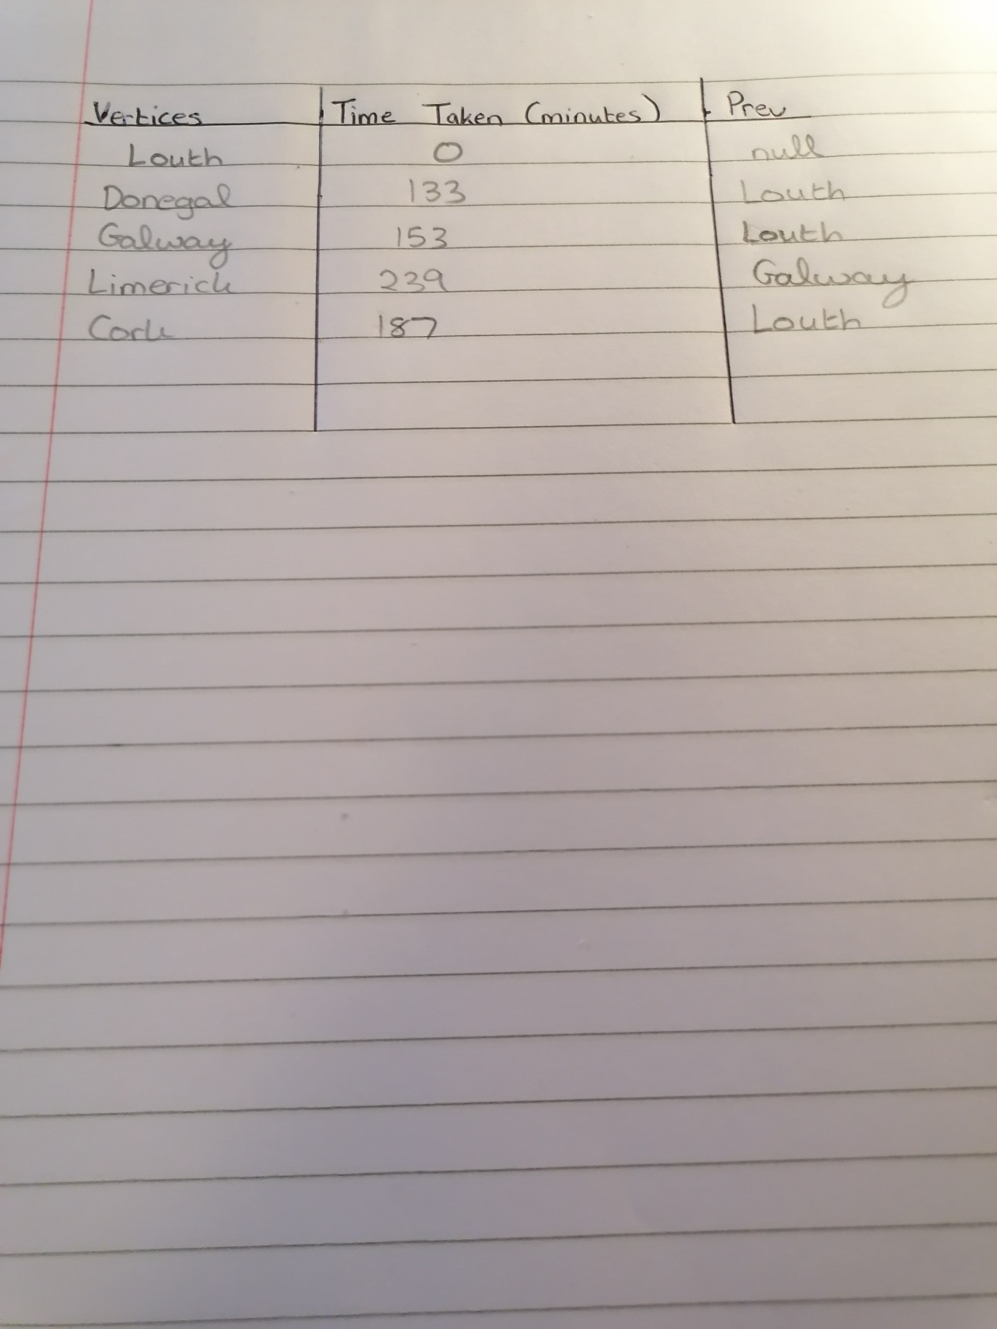

Question 2. Quick Sort
Question: Compare and contrast various approaches that can be used to select the Pivot in the quick sort algorithm.

Answer:
In short, the quick sort algorithm is just like the merge sort algorithm in the sense that it is another example of the divide-and-conquer recursive algorithm. This means that your collection of elements, or array of items that is to be sorted, is then organised into two partitions and then the Quick Sort procedure is called recursively to sort he two split partitions. In this case, a pivot is then used to help divide the elements to be sorted into two parts, where the Quick Sort algorithm will be able to sort them out.

In the Quick Sort Algorithm there are 3 different approaches and method in which the pivot is selected. Some examples include:

- Getting the Median of 3 Elements
- Using the first element as the pivot
- Randomly selecting the pivot

Getting the Median of 3 Elements
This method involves taking a sample of 3 elements from the collection of elements and then you must use the median, otherwise known as the middle value. The easiest way is by taking the first, middle and last numbers and then re-arrange these 3 numbers so that the smallest value is in the first position and the highest value will take the last position while the middle value remains in the middle. The major advantage of this method is that it enables to speed up the partition loop.

Using the first element as the Pivot
This approach is a lot less reliable compared to the other approaches. In the situation where the Input Array is random, then the algorithm will be able to perform the Quick Sort with minimal problems. However, in the event of the Input Array being pre-sorted, then the pivot must be the smallest element. When this happens, the performance of the algorithm will suffer as it will result in an O(N^2) complexity, and referring to the Big O Notation, is the worst situation.

Randomly Select a Pivot
From the list of the different methods as outlined above, this is generally considered to be a safer approach. But there is a drawback when using this method, and that random number generation can be expensive with respect to speed and task complexity. This is largely due to how the algorithm might need to sort through a large quantity of elements.

